Tableau Desktop Note

Tableau Desktop is a visualization tool, during the project, I tired to realize three different data sources to realize the Kaplan Meier curve

1. Directly connect to the Synthea data in csv format

Then I found when it comes to complex preprocess step, for example remove duplicate records or ensure the patient only took one of the medication would lead the scripts in the Tableau Desktop complicated and hard to understand thus I notice the appearance of Tableau Prep can do advanced preprocess and Tabeau can connect its output to do visualization, which push to the next stage

1. Using Tableau Prep to connect Synthea data in csv format and its output to connect Tableau Desktop

Then consider the data security, rather using csv file, we import those data into red database and then preprocess export data. But there are is no straightforward way to connect the redcap database to Tableau Prep, we need to figure out a way to connect redcap database to Tableau Desktop.

1. Intermediate to connect redcap database and Tableau Desktop

We choose jupyternote book using Jupytab as the intermediate, the advantage is it easy to set up and it can further contains security token and set the SSL which can secure it to some extent; however its shortage is it do not store data, each time need to make a request to ask the export data so that when there is some update in the database, we need to rerun the jupyter notebook, and the local server that contains the preprocessed data is still easy to be attack, the data security is still a concern. A more common way and can explore in the future is to use an intermediate database which can improve on the problem mentioned above.

Below shows how to use Tableau Desktop to do the Kaplan Meier curve after connecting to preprocessed data

1. Create a new workbook in tableau Desktop

Open a new workbook in tableau from File-> New, then you can get a window shown below

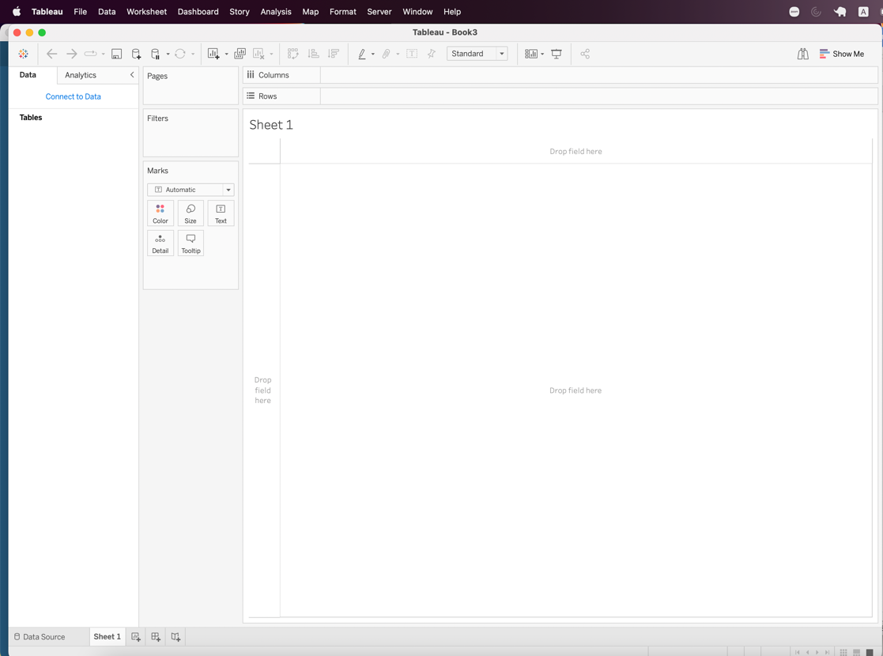

1. Connect data source

Through Data-> New Data Source, Under the To a File choose More… and select the Output. hyper which is the output from the Tableau Prep

1. Generate calculated field in worksheet

In this step, we back to the worksheet page and generate the required field used in Kaplan Meier plots.

Through Analysis -> Create Calculated Field... , we create the below fields

* Number of records

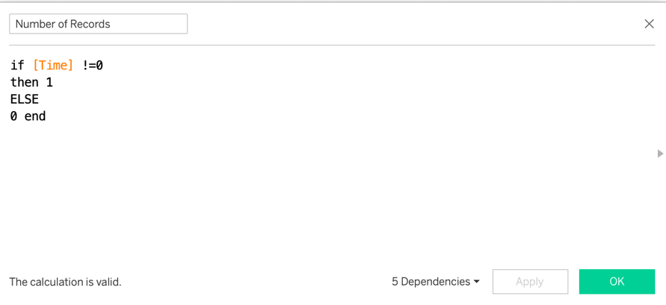

* Survival Probability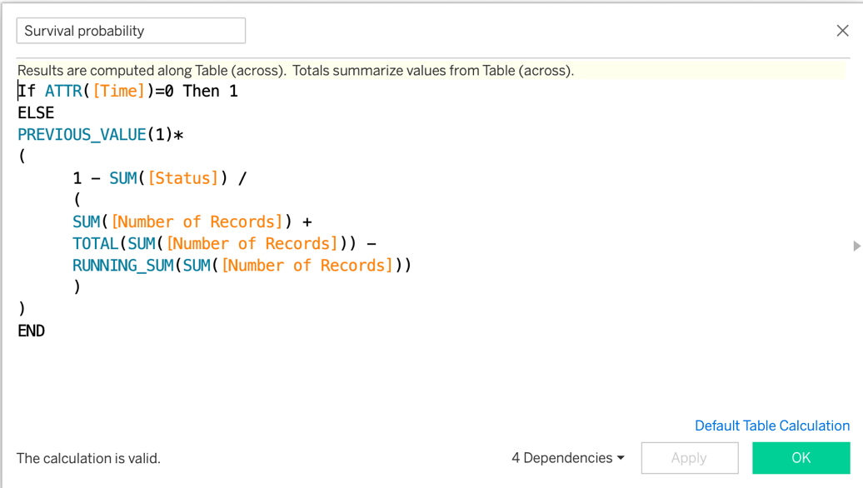
* Refer: <https://www.linkedin.com/pulse/advanced-survival-curves-tableau-part-1-chris-short/>
* Survival Probability dots



* Event happened

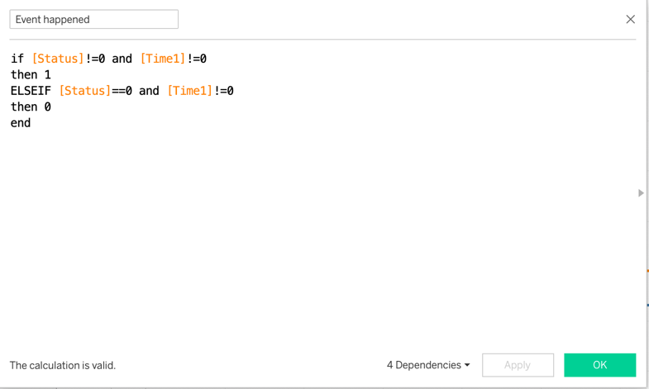

1. Create the plots
   1. Curve plots
   * Drag Time to the Columns and change to dimension
   * Drag Survival probability to Rows
   * Change path to second line type under Marks block
   * Drag medication to color under Marks block



* 1. Annotate point
  + Drag Survival probability dots to Rows
  + Change to dual axis right click on the Survival probability dots in the row

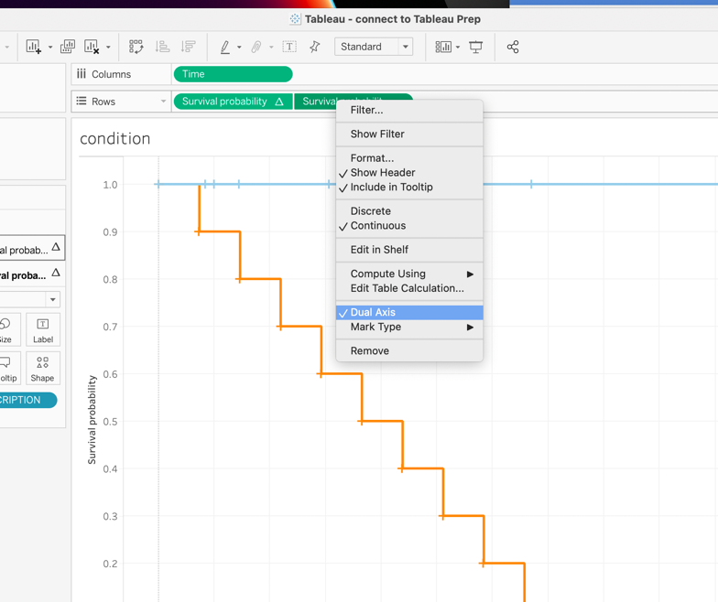

* + Edit axis to Synchronize Axis and hide the axis through untick the Show header

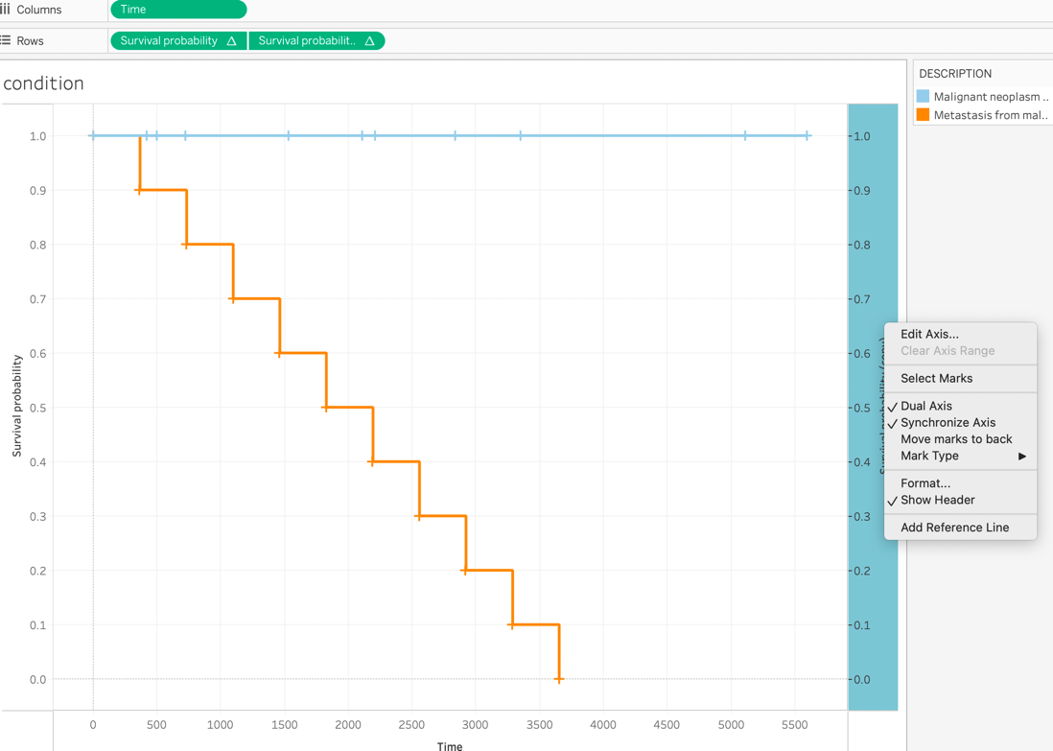

For adding Logrank test it required to integrate R with Tableau

1. Open Rserve

open R then

* + Install Rserve package
    - install.packages("Rserve")
  + Load Rserve package
    - library(Rserve)
  + Enter commands
    - Rserve() -> if there is error said

Fatal error: you must specify '--save', '--no-save' or '--vanilla'

Change to => Rserve(args = "--no-save")

Refer：<https://www.youtube.com/watch?v=g1VhXXOqlRE>

SOCK_ERROR: bind error #48(address already in use)

It means default port 6311 is already in use, then we check what process run on the address and terminate the process.

sudo lsof -i:6311 to get the detail(PID) of the process run on the address

kill -9 <PID>

1. Open tableau
2. Connect R and tableau

Help -> Settings and Performance -> Manage Analytics Extension Connection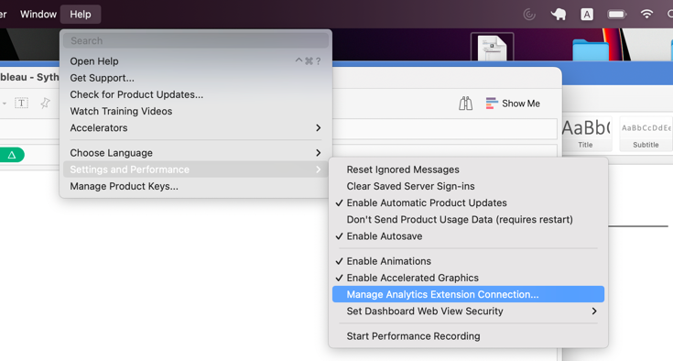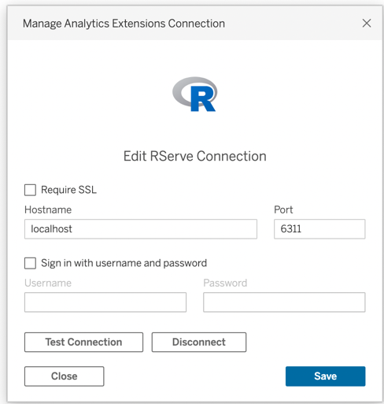

 The default Port for RServe is 6311

After checking the connection is successful, the next step is to create a new workbook and calculated field. To check the connection, simply click the Test connection, if successfully connected, it pops out the window 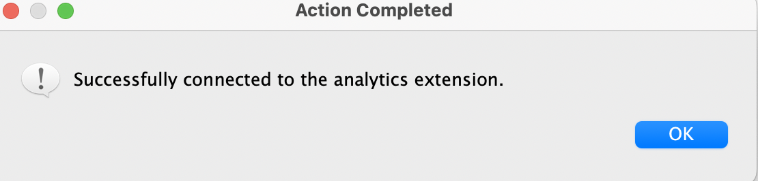

For calculated fields

* Index

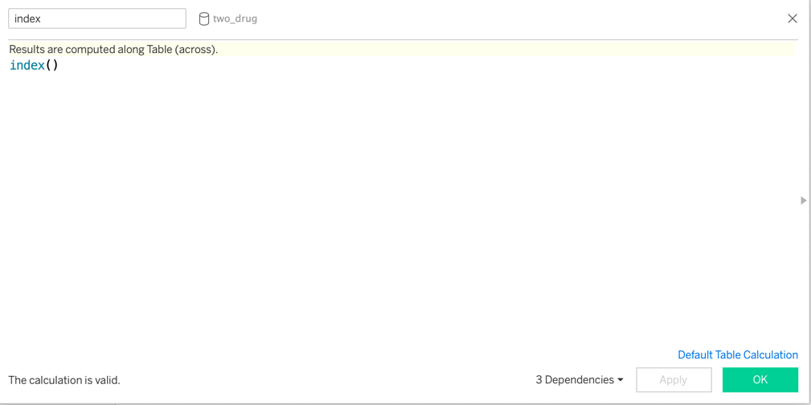

* LogRankTest pvalue
  + for two medication under same condition(cancer type)

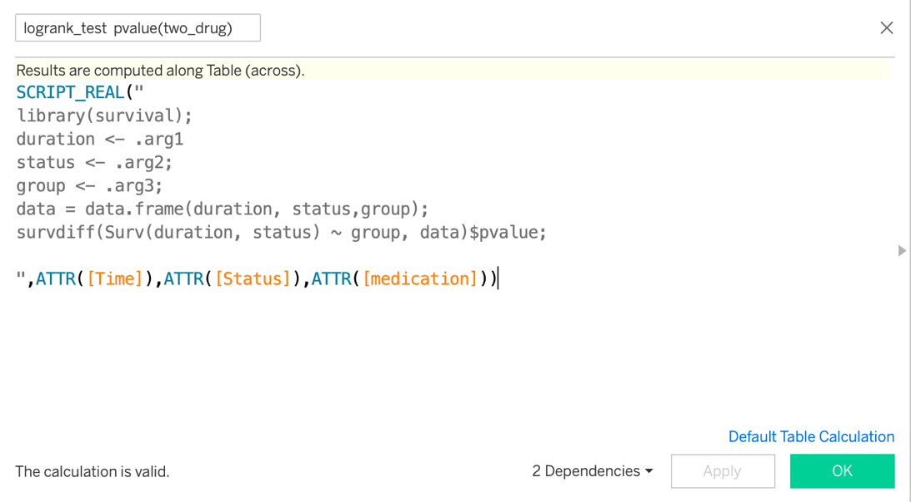

Note: the pvalue from log rank test can also be extracted from the CPH model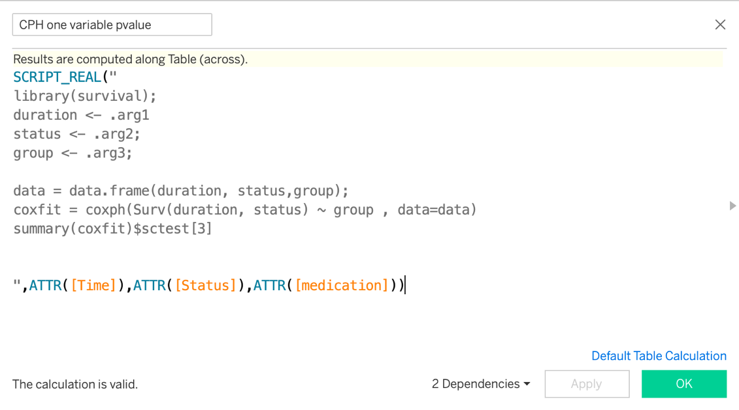

Note:

1. It needs to change the tableau aggregation setting to records level or errors shown below pop out

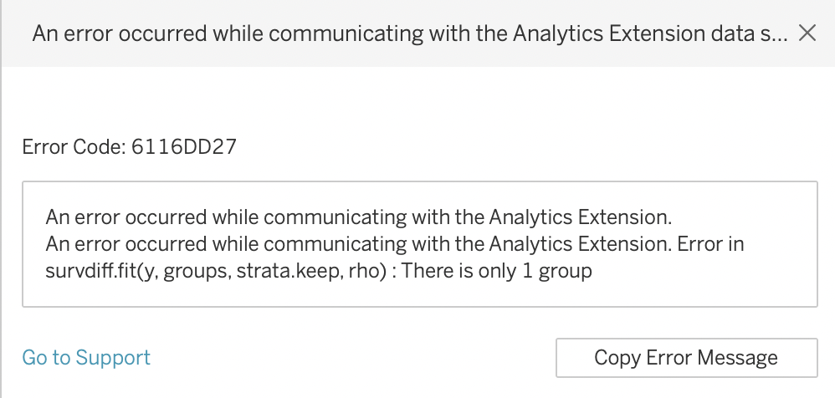

Click Analysis -> Aggregate Measures to ensure Aggregate Measures is NOT selected.

1. Inside logranktest pvalue calculated field

Put Rcode inside SCRIPT_REAL() and this function constrain the return value is real number; .arg1, .arg2, .arg3 corresponding to Time, Status, medication respectively.

The line survdiff(Surv(duration, status) ~ group, data)$pvalue is used to get the pvalue in LogrankTest

1. Since we change the tableau aggregation setting to records level, the p-value are computed for all rows. To only keep only one value, we filter by index and only keep the value at the first position.

For the cox proportional hazard model:

The limitation of the logrank test is it only can be applied on a single categorical variable to test whether it is significantly different if we want to quantify the difference or test on multiple variables(including both categorical variable and continuous variable)

Here we show an example still with two drug cases and add the age when the patient got cancer into consideration

a. Add calculated filed in tableau Prep

* 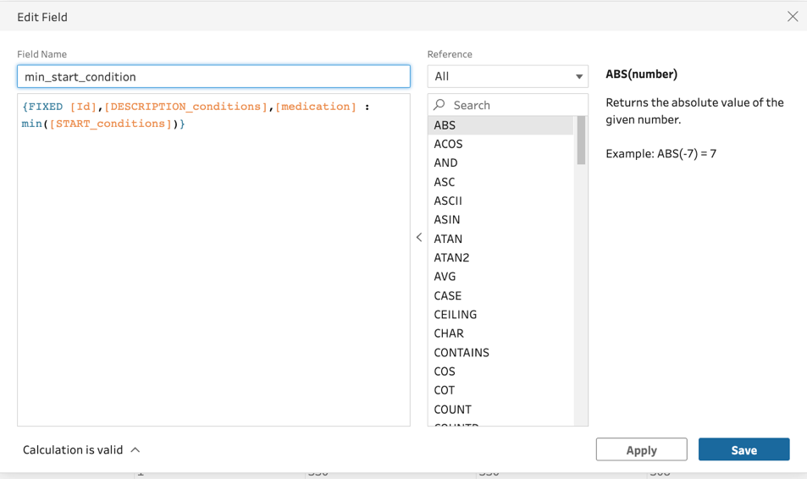
* 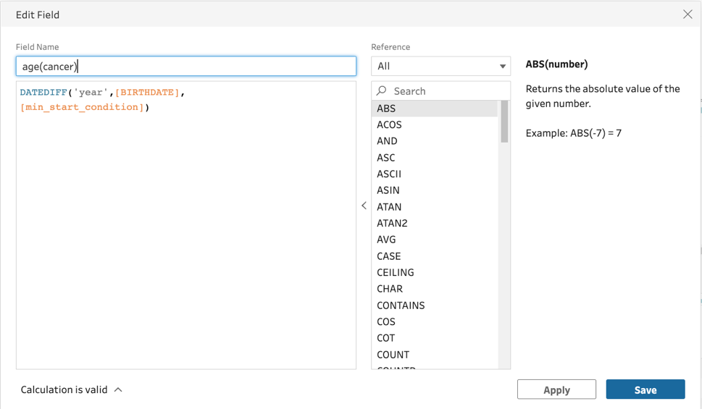

b. Add calculated field in tableau Desktop

- Cox multiple variables

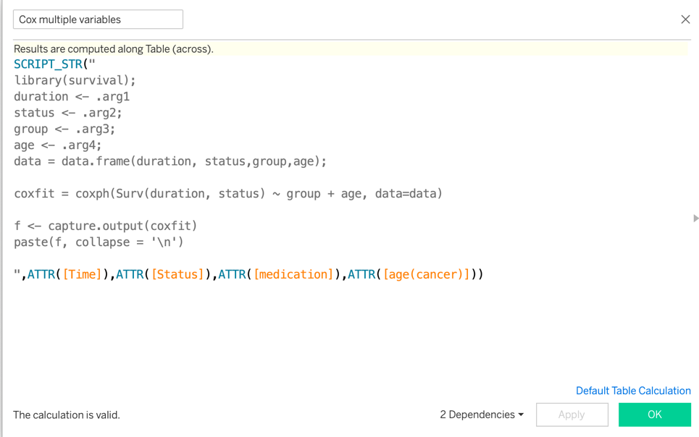

Note: SCRIPT_STR() returns the string output from R, we capture the information from the output from coxfit

1. Build the dashboard

Through Dashboard->New Dashboard; we can create a new dashboard and drag Sheets can add to the dashboard, if want to move the plots, we can click on More option-> floating points then can move freely.